Preparation of Full Papers in Two-Column Format for JUICE-2012 Proceedings

First Author, A., Second Author, B., and Third Author, C.
Line 1: Affiliation(s)
Line 2: Email Address(es)

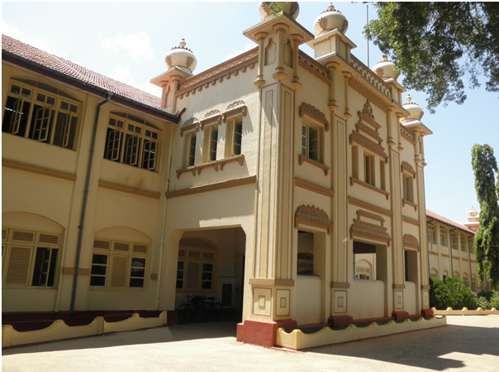

- (b)

Fig. 1: (a) Ramanathan Block (b) Crest of the University of Jaffna. Note that “Fig.” is abbreviated. There is a colon after the figure number. It is good practice to explain the significance of the figure in the caption.

Abstract— Abstract is a concise summary of the study and the second mostly read portion of a paper. The summary of your work for the JUICE-2012 should not exceed three hundred and fifty words. It should be a single paragraph.
Keywords — About four keywords or phrases in alphabetical order, separated by commas.

- Introduction
Introduction is the starting part of your paper and is also important. However, your introduction part should not exceed one page. The first paragraph should start with a broad statement and then narrow down to the research topic on the rest of the paragraphs.

- Helpful Hints

Title
Title is the most important part of a paper. It gets read first by the JUICE-2012 editors, reviewers, and later by the participants of the conference and the readers. The title of a paper is a concise summary of the main points of your paper. It should contain all the key elements of your study. You have to limit (the title of your article to the JUICE-2012) to 100 characters and spaces or less.

Template
Prepare your manuscript in full-size format on A4 paper. Please use this A4 template.

Type sizes and typefaces
Follow the type sizes specified in Table I. As an aid in gauging type size, 1 point is about 0.35 mm. The size of the lowercase letter “j” will give the point size. Times New Roman is the preferred font.

A4 margins: top = 19 mm, bottom = 40mm, side = 15mm.
The column width is 88mm (3.46 in). The space between the two columns is 4mm (0.16 in). Paragraph indentation is 3.5mm (0.14 in).

Left- and right-justify your columns. Use tables and figures to adjust column length. On the last page of your paper, adjust the lengths of the columns so that they are equal. Use automatic hyphenation and check spelling. Digitise or paste down figures.

Figures and Tables
TABLE I
Type Sizes for JUICE-2012 Proceedings
Type size (pts.) | Appearance
 | Regular | Bold | Italic
6 | Table captions, table superscripts
8 | Section titles, references, tables, table names, first letters in table captions, figure captions, footnotes, text subscripts, and superscripts
9 |  | Abstract
10 | main text, equations, first letters in section titles |  | Subheading
11 | Authors’ names
24 | Paper title

Position figures and tables at the tops and bottoms of columns. Avoid placing them in the middle of columns. Large figures and tables may span across both columns. Figure captions should be centred below the figures; table captions should be centred above. Avoid placing figures and tables before their first mention in the text. Use the abbreviation “Fig. 1,” even at the beginning of a sentence.
  - References
Number the citations consecutively in square brackets [1]. Punctuation follows the bracket [2]. Refer simply to the reference number, as in [3].
Number footnotes separately in superscripts. Place the actual footnote at the bottom of the column in which it was cited. Do not put footnotes in the reference list. Use letters for table footnotes (see Table I). Give all authors’ names; use “et al.” if there are six authors or more. Papers that have been submitted or under review should not be cited. Papers that have been accepted for publication should be cited as “in press”. In a paper title, capitalize the first word and all other words except for conjunctions, prepositions less than seven letters, and prepositional phrases.
For papers published in translated journals, first give the English citation, then the original foreign-language citation.
  - Abbreviations and Acronyms
Define abbreviations and acronyms the first time they are used in the text, even if they have been defined in the abstract. Do not use abbreviations in the title unless they are unavoidable.
  - Equations
Number equations consecutively with equation numbers in parentheses flush with the right margin, as in (1). To make your equations more compact, you may use the solidus (/), the exp function, or appropriate exponents. Italicize Roman symbols for quantities and variables, but not Greek symbols. Use an en dash (–) rather than a hyphen for a minus sign. Use parentheses to avoid ambiguities in denominators. Punctuate equations with commas or periods when they are part of a sentence, as in

a + b = c. (1)

Symbols in your equation should be defined before the equation appears or immediately following. Use “(1),” not “Eq. (1)” or “equation (1),” except at the beginning of a sentence: “Equation (1) is …”
  - Other Recommendations
The Roman numerals used to number the section headings are optional. If you do use them, do not number Acknowledgment and References, and begin Subheadings with letters. Use two spaces after periods (full stops). Hyphenate complex modifiers: “zero-field-cooled magnetization.” Avoid dangling participles, such as, “Using (1), the potential was calculated.” Write instead, “The potential was calculated using (1),” or “Using (1), we calculated the potential.”
Use a zero before decimal points: “0.25,” not “.25.” Use “cm³,” not “cc.” Do not mix complete spellings and abbreviations of units: “Wb/m²” or “webers per square meter,” not “webers/m².” Spell units when they appear in text: “…a few henries,” not “…a few H.” If your native language is not English, try to get a native English-speaking colleague to proofread your paper. Do not add page numbers.

- Units
Use either SI units as primary units. English units may be used as secondary units (in parentheses). An exception would be the use of English units as identifiers in trade, such as “3.5-inch disk drive”. If you must use mixed units, clearly state the units for each quantity that you use in an equation.
- Some Common Mistakes
The word “data” is plural, not singular. The subscript for the permeability of vacuum₀ is zero, not a lowercase letter “o”. In American English, periods and commas are within quotation marks, like “this period.” A parenthetical statement at the end of a sentence is punctuated outside of the closing parenthesis (like this). (A parenthetical sentence is punctuated within the parentheses.) A graph within a graph is an “inset,” not an “insert.” The word alternatively is preferred to the word “alternately” (unless you mean something that alternates). Do not use the word “essentially” to mean “approximately” or “effectively.” Be aware of the different meanings of the homophones “affect” and “effect,” “complement” and “compliment,” “discreet” and “discrete,” “principal” and “principle.” Do not confuse “imply” and “infer.” The prefix “non” is not a word; it should be joined to the word it modifies, usually without a hyphen. There is no period after the “et” in the Latin abbreviation “et al.” The abbreviation “i.e.” means “that is,” and the abbreviation “e.g.” means “for example”.

- Conclusion
In recent years, research papers seem to end with conclusion. This can be well understood because otherwise the further research sub section could stay as the last message from the article to a reader, and it will direct thinking missing the main results.

Acknowledgment
The preferred spelling of the word “acknowledgment” in America is without an “e” after the “g.” Try to avoid the stilted expression, “One of us (V. A.) thanks …” Instead, try “V. A. thanks …”.

References
- Murzynski, J. and Degelman, D. “Body language of women and judgments of vulnerability to sexual assault”. Journal of Applied Social Psychology, 26, pp. 1617-1626, 1996.

- Srisatkunarajah, S. and Jeyakumar, V. “Distinguishing a global minimize from local minimizers of quadratic minimization with mixed variables”, Pacific Journal of Optimization, Vol.6, No. 1, pp. 65-74, 2010.

- Wei, L. and Chen, H. “The ripple effect of natural disaster on the agricultural industry chain”, In Proceedings of the 2010 Fourth International Conference on Management of e-Commerce and
e-Government (ICMeCG), pp. 85-89, 2010.
- Sasikaran, S., Kirubahary, S., Balakumar, S. and Arasaratnam, V. “Microbial Analysis of Bottled Drinking Water available in Jaffna Peninsula”, In Proceedings of the Abstracts of Jaffna University International Research Conference (JUICE- 2012), pp198, 2012.

